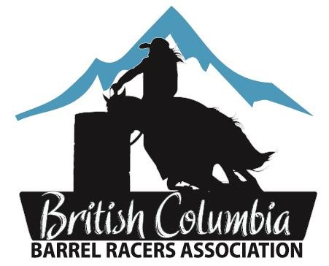

Dear Potential Sponsor,

The BC Barrel Racers Provincial Finals will be held September 13-15, 2024 in Kamloops BC. Plans are underway, and it is time to seek sponsorship for some of our awards.

**A few key details about the BCBRA:**

* Founded in 1969
* Non profit society, run by a board of 13 directors
* In 1991 - 93 members to 2024 – 674 members!
* Promoting the sport of barrel racing by facilitating jackpot 4D barrel racing events that offer options to every family member from all levels of knowledge, skill and financial background
* Youngest member in 2024 was 2, and the oldest79.
* In 2024, awarded approximately $150,000 in prize money and awards
* 650 entries at the 2024 finals

All the BCBRA sponsors will be listed in our own website: ww[w.bcbra.com](http://www.bcbra.com/)

The BCBRA members are grateful to all their sponsors, past and future. Your generosity helps reward a year of hard work and dedication, while supporting BC’s Horse Industry, and Amateur Sport.

Please review the enclosed sponsorship package and join in the promotion of one of the fastest growing sports in BC.

Sponsor cheques may be mailed to:

**BCBRA c/o Karen Yaworski**

**Box 1340**

**150 Mile House, BC V0K 2G0**

Sincerely,

Karen Yaworski

Sponsorship Director

Phone: 250-302-2301

Email: bcbrasponsorship@mail.com

# BCBRA Finals Awards 2025

**Barrel Racing Saddle Sponsor Sponsorship Value: $ 1500.00** Saddle Sponsors will receive:

* Sponsor name on both sides of the saddle
* Professional photo of the saddle winner
* Invitation to the BCBRA awards ceremony to be held at Finals
* Advertising in the arena during the Finals (banners or signs to be provided by sponsor)
* Acknowledgement and thank you on our web site [www.bcbra.com](http://www.bcbra.com/) and in the PA Announcements throughout the Finals Weekend.

## Barrel Racing ½ Saddle Sponsor

**Sponsorship Value: $ 750.00** Saddle Sponsors will receive:

* Sponsor name on one side of the saddle
* Professional photo of the saddle winner
* Invitation to the BCBRA awards ceremony to be held at Finals
* Advertising in the arena during the Finals (banners or signs to be provided by sponsor)
* Acknowledgement and thank you on our web site www.bcbra.com and in the PA Announcements throughout the Finals Weekend.

## BCBRA Trophy Buckle Sponsor

**Sponsorship Value: $ 300.00** Buckle Sponsors Will Receive:

* Sponsors Name engraved on back of buckle
* Professional photo of the buckle winner
* Invitation to the BCBRA awards ceremony to be held at Finals
* Advertising in the arena during the Finals (banners, provided by sponsor)
* Acknowledgement and thank you on our web site www.bcbra.com and in the PA Announcements throughout the Finals Weekend.

## BCBRA Horse Blanket Sponsor

**Sponsorship Value: $175.00**

Blanket Sponsors will receive:

* Sponsor name embroidered on the blanket
* Professional photo of the blanket winner
* Advertising in the arena during the Finals (banners, provided by sponsor)
* Acknowledgement and thank you on our web site www.bcbra.com and in the PA Announcements throughout the Finals Weekend.

## BCBRA Product or Cash Donation Sponsor

If you would like to support the BC Barrel Racers Association, but would like to do so with a product (with discussion and awards director approval) or with a cash donation, we would be more than pleased to accept and to show our appreciation of your support we would like to offer you;

* Acknowledgement and thank you on our web site www.bcbra.com and in the PA Announcements throughout the Finals Weekend.

**SPECIAL NOTE:** In order to have the proper recognition on blankets, buckles or saddles, we request that you submit your payment prior to August 31, 2025. We appreciate your generosity.

**Finals Year** _____________

# BCBRA Sponsorship Incentive Form

Name of Company: _________________________________________________________

Contact Name: ______________________________________________________________

Company Address: _________________________________________________________

Phone: _______________________________________ Postal Code: _________________ Website address: __________________________________________________________

|  |  |
| --- | --- |
| Saddle  ½ Saddle  Buckle  Blanket | $1500.00 _____________ $750.00 _______________ $300.00 _______________  $175.00 _______________ |

or

Sponsorship Amount $ ______________ or

Product (*pre approval required*):________________________________________________

*Contact the Awards Director for approval prior to submitting your “product” donation. Contact Courtney at: cpm@live.ca*

BCBRA Member Name:__________________________________ Membership # ______

If possible, please enclose a business card or logo

**MEMBER INCENTIVES:** If a member brings in:

$1500 In sponsorships, member will receive 1 paid for entry into the current years’ finals.

$500 In sponsorships, member will receive next years’ basic membership free. $2000 In sponsorships, member will receive both incentives.

\**Refund of entry fees &/or membership card will be sent to the recipient after the current years’ finals.*

*\*\*In order for the BCBRA to distribute the above incentives, this form MUST be filled out and submitted to the Sponsorship Director, Karen Yaworski*, *prior to finals.*